The fundamental of the original game is a character on a 2d plane that is constantly in motion, by adjusting the direction of where it is facing it navigates through a maze. The objective of the game is to collect all the orbs laid out throughout the maze, whilst avoiding 3 ghosts that are released from the centre of the maze incrementally. The Pac-Man has 3 lives to collect to collect all the orbs. After being caught 3 times the user dies, and the game is over. Despite its age, pacman remains popular today possibly due to its retro style and easily understandable rules. In this project I intend to build my own version of pacman, retaining its core mechanics while introducing new features that increase replay ability and challenge. To achieve this, I will analyse the original game and similar maze-based games, whilst discussing with stake holders to create requirements for an improved game.

The demographic for my game is people of all ages. This is because research shows that all ages are represented when it comes to the people who play computer games, which is why I have chosen this demographic because the game is simple and intuitive for all ages.
Regarding the testing for my project, I will be using peers from the Sixth as a form of black box testing. This is so the program can be tested by someone externally who doesn’t know the inner workings of the software. This allows me to see what players experience while playing the game and how it can be improved to allow for a more engaging game.
My stakeholders will test the game from a consumer standpoint and will test the game from a perspective of how engaging the game is, how easy the game is to play and the creativity aspects. As well as this they will also give me feedback as to which part of the game, I should improve on to make the game more user friendly. An example of feedback given to me is to implement a ghost that could shoot pellets, to try and test themselves and their skill at the game. Another piece of feedback that was given to me was to create multiple varied game modes not just difficulty for the use to try and play, however I have decided not to implement this feature as I feel it would mean less time to be implemented, which may result in a product which has errors. This is why I am sticking with the basic 3 game modes easy medium and hard mode to be my primary game modes.
However, as a form of white box testing, I will be using peers and teachers from my Computer Science class to test my game from a game design and code efficiency standpoint. This will allow for an in-depth testing because it would allow for all the possible steps to be taken and tested, in contrast to the other stakeholders who would be testing for usability.
Some examples in the way they will be testing is if the game mechanics are fun and understandable as well as the velocity of the player and ghosts. However, my colleagues would be testing from a different standpoint; they will be testing for every movement option in the game to see if there are any results that are unexpected.

Research the problem: Similar problems to pacman include games like Ms pacman; this research focuses on grid-based movement, enemy avoidance and progressive difficulty, as these are considered core elements in my pacman based game. Ms Pacman improved on pacman by introducing multiple maze layouts and faster enemy movements. Alike pacman the implementation of a physics engine or certain boundary parameters would allow for realistic collisions to take place. Furthermore, Ms Pacman's implementation of bonus items such as cherries would increase the retention from players. The first thing to do is compare the arcade game to their online versions and find out what makes the online versions of these games so successful. Arguably, the main reasons for the game’s success are the ease of the navigating and playing the game, which is due to the simplicity of the GUI (Graphical User Interface).
The game controls are intuitive such as using arrow keys to move as well as constant velocity of the pacman being controlled. Ms Pacman is considered an improvement over the original pacman due to the introduction of dynamic mazes where it uses 4 unique mazes with different colour schemes to retain user attention, preventing players from relying on memorised movement patterns. Another significant improvement over pacman is the inclusion of bouncing bonus fruits: such as pretzels, pears, and bananas, which move through the maze and enter and exit through “warp tunnels” rather than appearing in fixed locations. This introduces a strategic concept of risk to reward as players must determine whether they can make it to the fruit, whilst avoiding the constant ghosts.
One significant addition is the inclusion of bouncing bonus fruits, such as pretzels, pears, and bananas, which move through the maze and enter and exit via warp tunnels rather than appearing in fixed locations. This introduces a risk-and-reward element to the gameplay, encouraging players to make strategic decisions while avoiding enemies. This feature allows players to improve their skills by seeing possible routes that could be made to the fruits.
Vibrant colours to make sure that people with colour blindness can still play the game without it interfering. This is to increase the accessibility of the game.
Clear section to show score and high score
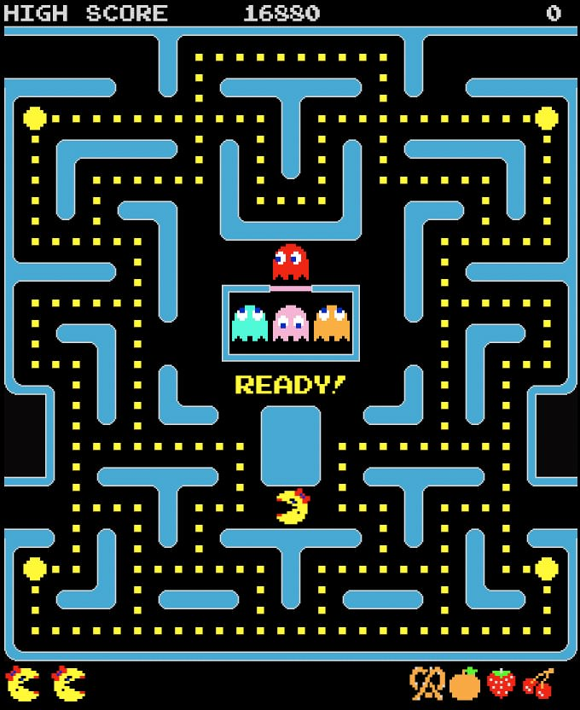
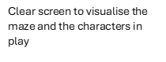
Clear panels to show collected fruit and lives remaining
Larger sized power orbs to visually show different orbs
An AI element in the game is the ghost’s pathfinding, to fins the most efficient route to the player using multiple algorithms for the different ghosts
Clear screen to visualise the maze and the characters in play

Another game analysed was Bomerman a grid based retro maze game. It’s known for its emphasis on spatial awareness, timing(bombs) and enemy ai’s. Players must navigate through a closed maze in a fast-paced environment using bombs to clear a path, in attempt to kill enemies. The online version also allows for multiplayer compatibility as the enemies can be real people instead of ai. The research on this game gave me the insight to add my own player abilities.
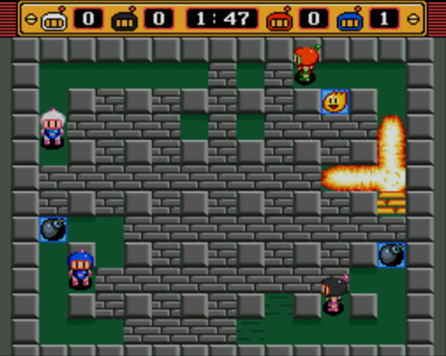
Clear bar to view time and points per player
The colour schemes of the board allow for an extreme contrast which allows for the players to see the game
clearly.

Bomb animations allow for retaining player attention

Powerup blocks allowing player to receive buffs

As well as researching these games I’ve also decided to have an interview with stakeholders to get their initial requirements for the game. This interview will be conducted to find the basic requirements from the stakeholders, which contributes to how the game will be created.
The main three headings are: what makes a good game, what types of visuals are wanted and what types of challenges or abilities are wanted. Based on these headings I’ve broken them down further with multiple different questions per heading so the requirements can be precise and requirements linked to features of the game.

What makes a good game?
- What frustrates you with maze games?
- Should some sort of scoring system be implemented?
- How would you like to interact with the game?
What types of extra features are wanted
- What types of abilities would you want from the game?
- What types of challenges would you want from the game?
What game mode(s) would you want from the game
- Do two-player game modes make the game better or worse and why?
- What is your opinion on different levels of difficulty?
- If you could have a custom game mode, what would you include?

Interview with stakeholders about initial requirements:
What makes a good game?
What frustrates you with maze games?
Repeated levels, and no difficulty scaling, leading to boring repetitive gameplay
Should some sort of scoring system be implemented?
Yes, this is because it sets a goal for the players and tells you how well you’re doing in the game.
How would you like to interact with the game?
Using arrow keys and a special key for extra game mechanics for example f

What types of extra features are wanted?
What types of abilities would you want from the game?
Potential abilities for the game could be, an ability for the player to shoot projectiles at ghost, preventing points in the game where it is impossible to progress
What types of challenges would you want from the game?
Dynamic mazes less repetition and difficulty scaling, possibly ghosts that can shoot pellets as well
What types of visuals are wanted?
How would you want the menu system to be displayed to the users?
I would like it to be displayed in a way so the information that’s being displayed is concise so that it doesn’t take up the entire screen and so that theirs a keypress that can pause the game too.
How would you like the point system and lives displayed?
I would like it to be displayed so that its easily understood and eye catching for players
What game mode(s) would you want from the game?
Do two-player game modes make the game better or worse and why?
We’d think a two-player game mode would make the game better because it would allow you to play against your friend to see who’s better at the game.
What is your opinion on different levels of difficulty?
Different levels of difficulty would be entertaining as it would reduce the amount of repetitiveness that the game may struggle with
If you could have a custom game mode, what would you include?
I would have a game mode with rapid powerups, and faster ghost called extreme mode that would challenge the player
Requirements Table:
Table 1: Requirements for stakeholders
Stakeholder | Requirement | Description | Measurable data | Priority (High/Med/Low) | Justification
Alex (Child aged 14) | Req1 | Intuitive arrow key movement, easy layout | Collect first pellet within 30 seconds | High | Allows for easy understanding of game mechanics allowing users to focus on gameplay
Yusuf (Child aged 13) | Req2 | Interesting player abilities | Implementation of player being able to shoot pellets | High | Allows for greater game variety and dynamic gameplay
Jordan (sixth form student) | Req3 | Random maze generation | Achieve 90% unique layouts | High | Enhances replay ability which was the survey’s top request
Ahmed (sixth form student) | Req4 | Scaling ghost difficulty | Speed +20% after a certain objective is met | Med | Creates a challenging aspect to increase enjoyability
Mr. Read (Parent) | Req5 | Offline capabilities | Runs without network | High | Safety for young users from the internet
Ms. Patel (Parent) | Req6 | 2 player game modes | 2 sets of key binds with 2 active PacMan | Low | Creates a unique aspect from the base pacman
Essential features of a computational solution explaining these choices:
The first stage of solving a problem is identifying if that problem can be solved using computational methods. It’s plausible to suggest a problem is computable when it can be solved using the below methods. There are some conditions when it comes to determining if a problem is computable, one of the main ones being if the problem can be solved within a finite and realistic time.

Computational Method | How it can be incorporated | Justification of use
Abstraction | This computational method can be implemented within my game, by getting rid of unnecessary details such as the colour schemes of the background. Furthermore, the maze can be treat as a collection of nodes and blocks numbering each wall block, orb, fruit, power orb. | Abstraction is the process of getting rid of unnecessary details of the problem. This is so I can focus on the  elements that need to be coded instead of worrying about unnecessary details.
Decomposition | Decomposition can be  implemented in my game by breaking down the large  problem of Pamanv2 into smaller manageable  problems. An example of decomposition is breaking down the game into smaller problems such as the User Interface and the game itself. | Decomposition is the  process of breaking down a large problem into multiple smaller problems. This  allows for the problems to be examined in higher detail.  The solutions to the smaller problems then act as the building blocks of the solution of the bigger  problem.
Thinking ahead | This can be incorporated in my game by designing the program in a way that allows updates to be made to the game in the future. | Thinking ahead is the process of coding your solution in a way that is  handled in the best possible way in terms of time to execute and the amount of  memory needed.
Algorithmic Thinking | Algorithmic thinking can be implemented into my game by designing a step-by-step plan, implementing that plan and testing that plan. After this any changes can be made. | Algorithmic thinking is a way of working out a solution through the clear definition of the steps needed.
Performance modelling | Performance modelling can be used in my project by  measuring the response time | Performance modelling can be used to understand how  the program will behave

Performance modelling(continued) | taken, to measure any.  issues, which can be used to address performance issues. | under different load conditions and constraints.
Pipelining and thinking concurrently | This can be used in my  project because my game runs at a constant frame rate, which means the  program can’t wait for an instruction to be executed.  Thinking concurrently can be implemented because it  would allow for prototypes of my game to be implemented, because multiple different things are being worked on at  the same time. | Pipelining is a technique used by the CPU, which allows it to execute multiple  instructions simultaneously.  Thinking concurrently is the process of working on multiple problems at the same time.
reusability | This can be implemented into my project because there are a lot of reusable elements in my game, such as buttons and ghosts ai which allows relevant modules and classes to be made. | This technique refers to the degree to which a method, or software component can be used again in a new application with minimal or no modification.

Limitations of the proposed solution
One of the main limitations of the proposed solution is that this games’ audience is for people playing on computer, which means that people who play games on their phones or tablets won’t be able to access the game. This is due to pygame, the module used to build the program, is not mobile friendly.
A lot of many modern videogames have a tutorial about their game or a “tutorial”, which is could be useful for new players because it allows them to get used to the controls and the constraints of the game. I would like to include this in my game, but due to the time constraints I don’t think I will be able to. However a way it can be implemented is by adding a screen, which can be accessed through the main menu, which explains the rules of the game to the player, if they don’t have experience playing the game. Advanced players might find ways to trick the A* algorithmic ghosts. Moreover, the proposed maze generation may only be semi-procedural which conducts controlled randomness for fairness, which means we don’t achieve full randomness.
Furthermore, there are technical limitations where, there may be noticeable performance constraints on low end hardware, for example PyGame at 60fps on 2ghz CPU handles 30x30 mazes but larger 50x50 drops to 45fps without optimization. This would make it hard to play on older PCs. Furthermore, with the proposed solution we are assuming that all players are comfortable with solely arrow keys when some demographics would rather play with wasd, touch screen or mouse movements.

Specify the proposed solution
Software and hardware requirements
I will be using Python as my programming language and PyGame as my game engine.  Python: 3.8+ and pip for libs such as NumPy 1.21+ | My reasoning for using PyGame is that it allows for event handling and display to be easily implemented into my game  The use of libraries such as NumPy was to calculate collisions between the ghosts, walls and the player(s). Handling vector data for the grid-based movement  Another reason I’ve chosen PyGame is that it’s a library that can be used on windows, macOS or Linux.
I will be using the Windows operating system | This is because Microsoft’s Windows is the most used operating system in the world  accounting for 67% share of the desktop, tablet and console OS in August 2024, which allows my game to be played by a majority of  the target audience (15).
Software requirements
Development of the program will be conducted through vs code with python extension and Git for version control | Supports an efficient and structured programming environment which features syntax highlighting, debugging and error detection.  Git was used to prevent loss of work and work in iterations to previous developments

Operating System: 64-bit Windows 7 or later or OS X 10.11 or later | This is so it can make efficient use of the CPU. A reason for this is that a lot of processes are being run in the game and the processor needs to be powerful enough to manage them simultaneously.
Processor requirement: 1.5GHz or faster | This is because PyGame uses software rendering, which means it relies on the CPU to draw the graphics making it less efficient for complex scenes, however this is irrelevant in my game as there won’t be many “Complex scenes”.
Minimum RAM: 2GB  Recommended RAM: 8GB | This is the lowest memory required to have an interpreter open without many lag spikes. The recommended RAM allows for the user to manage large datasets and run multiple  applications simultaneously without any lag.
Minimum storage: Python 10GB Minimum storage: VS code 200MB  Recommended storage: 100GB | This are both the minimum storages needed to program using either of these editors.  The SSD accelerates the work, allowing for faster access the files and processing, which is necessary when working with large amounts of data.
Monitor | This is so the game can be displayed to the player.
Keyboard | This is so the player can interact with the game as well as the GUI (Graphical User  Interface).
speakers | To listen to game audio, including sound effects and music
Hardware Requirements
All the hardware requirements were found on geeksforgeeks.org (3).

Success Criteria:
The following points are the success criteria for my game, which are split up into essential and desirable. This is because it is better to include all the essential features, rather than the desirable functions, this is so the game fully functions which allows for the desirable functions to be added later. I may not have enough time to add the desirable functions but at least have a fully functioning game.
Essential:
Success Criteria | Req ID  linked | Description | Justification of why it’s an essential success criterion
Have a user-friendly Graphical User Interface (GUI) | Req1 | This is so that the players can navigate their way through the game with relative ease.  This can be done with the implementation of features such as buttons because if a specific button is clicked a specific action is carried out. | This is essential to the game because a user-friendly GUI means that players will have a better playing experience and they will more likely want to return to the game and play it again.
Random maze generation | Req3 | This is because through the survey this was the most requested feature towards the game | This is essential because it improves the players adaptability creating a challenge which will make the users want to play the game more  which is a major reason as to why the game should be dynamic and not static.
Scaling ghost difficulties | Req2 | This feature involves the behaviour and difficulty of the ghosts as the game progresses. This could include increasing movement speed and implementing the orb shooting ability | Scaling ghost difficulty is important as It allows the game to be more challenging over time. This way the game is not repetitive and more engaging for the player
The implementation of Artificial Intelligence (AI) | Req3 | This feature involves using Artificial intelligence to control the behaviour of the ghosts in the game. The Ai will react to the players position and make decision potentially through a* algorithm. | Machine learning is a branch of Artificial Intelligence which focuses on making computers imitate the way humans behave (IBM, 2025). Implementing the use of machine learning would also be too time consuming because hundreds if not thousands of images would be necessary to train the model to behave like a human player.

Desirable
The following success criteria are desirable as they will only be implemented after the essential success criteria are completed to make sure that the game is fully functional before additional features are added.
Success Criteria | Req ID  linked | Description | Justification of why it’s a  desirable success criterion
There’s a leaderboard function | Req1 | This can be implemented in a game mode such as a time trial; to show the players name and the time they took to complete the game, and when the leaderboard is being accessed by the players the top 5 quickest times are outputted to the player so they will know who has the quickest time and how much they have to improve by to be on the top of the leaderboard. | There is a time restriction created due to the fact I’m taking other A level courses; however a leaderboard function would promote competitiveness to the game, this is because the players would feel like they’re competing against previous high scores. They may also see improvements while playing the game, which can lead to players not returning to it.
Two player modes | Req6 | This would provide a local two player mode in which each player would play against the other. This is  because each player would be assigned a coloured Pacman they would have to collect as many orbs as they can whilst avoiding enemies. This is so a competitive version of the game is available to be played by the player(s). | There is a time restriction created due to the fact I’m taking other A level courses. Another reason this success criteria is desirable is because it would require the use of multithreading, which is extremely complex and time consuming to implement (7) .
Projectile shooting ability | Req2 | This refers to the player being able to fire projectiles in the game such as orbs. | There is a time restriction created due to the fact I’m taking other A level courses. However, Its inclusion adds a new gameplay mechanic that enhances player interaction and variety in gameplay. Creating a more engaging and enjoyable experience
Offline capabilities | Req6 | The game can be played without an internet connection thanks to this feature. This is because all of the game's essential components including levels, graphics, and sound effects are kept locally on the user's device, this way the game can run completely offline. | There is a time restriction created due to the fact I’m taking other A level courses. This enhances usability and accessibility, particularly for users with inconsistent internet access. Additionally, ensuring offline functionality increases the game's agility.

Design of the solution
My pacmanv2 game implements a simple and intuitive control system using arrow keys which supports young players. Human Computer Interaction (HCI) is a multidisciplinary field on the design of the technology; however, the focus is on the interaction between the user and the computer.
Methodology
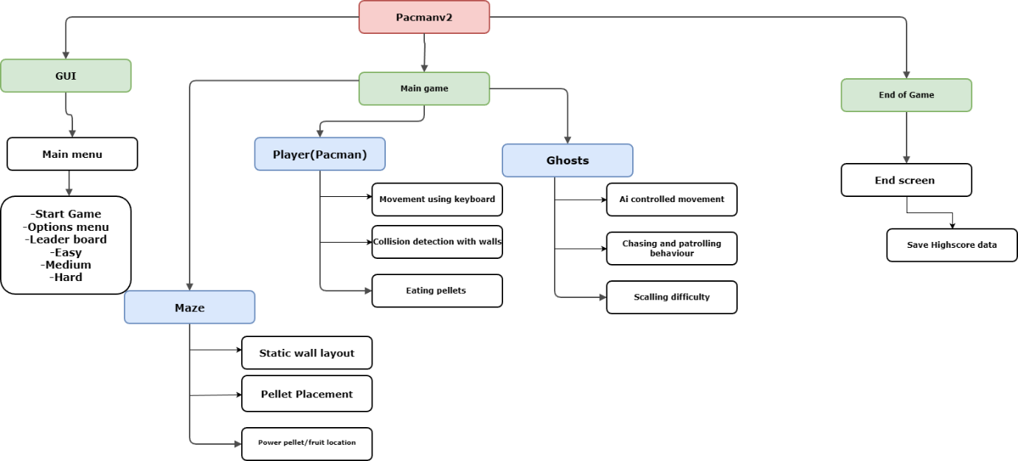
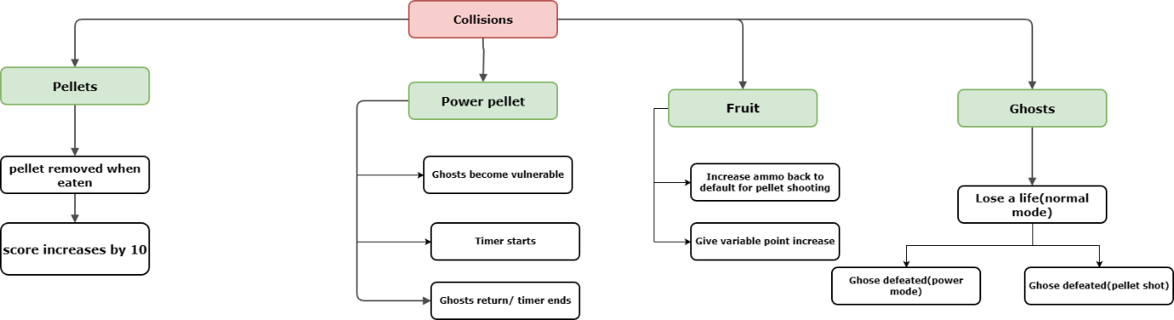
During the development of this project, I will be implementing RAD (Rapid Application Development), which is a type of agile methodology, instead of using another type of methodology such as waterfall. This is because when using a RAD methodology to create the solution prototypes can be created throughout development, so the stakeholders can then give feedback. This is extremely important because it means the stakeholders are allowing for any changes to be made during development, so, the product is to the liking of the stakeholders. However, if the waterfall cycle was used the stakeholders are only included in the development cycle when the user gives the requirements and when they test the product. The disadvantage of using the waterfall cycle is when the stakeholders are testing the product it may not be what the user wanted.

By implementing the use of a top-down modular design, this allows me to identify what I need to do before developing the program, because I can break down each part of the problem into more depth. This allows me to use the computational thinking skill “Thinking Ahead” to determine inputs and outputs that are needed for the game to function properly. Another computational thinking skill that can also be implemented here is “Thinking Logically”, because I will be able to work out what decisions need to be made and where they need to be made. This will give my coded solution structure so the problem can be solved more efficiently. I have broken down the game into 3 main problems and will expand on each of them as collisions is a large part of my game, I also implemented a top down modular design to showcase what collisions are possible within the game. Each solution to the sub programs will be used to create the end game.

Graphical User Interface:
This will determine what is displayed to the user depending on which pathway they followed, in the user interface.
The first thing displayed is the Main Menu, where there will be buttons with associated key binds, which will lead the player to the appropriate screen depending on which path was followed. The buttons on the Main Menu are the: start, control, easy, medium and hard buttons. Each of the buttons will display a different screen. When these screens are displayed, there will be a way for the player to go back to the previous screen, which would be another keybind.

Main Game:
This encompasses the gameplay itself and what needs to be done to make the game playable and enjoyable.
This is where the player plays the game, where all the processes take place. The main processes required by the stakeholders are the behaviour of the player, the act of shooting pellets, the collisions, input from the user while the game is being played and score monitoring.
The behaviour of the Player:
- When the game is first loaded the Player is presented near the bottom middle of the screen.
- The movement of the player is controlled by arrow keys and WASD (if implemented).
- When an orb, special orb or fruit has been collected, it should be removed from the screen.
The behaviour of the Pacman:
- When a key bind is clicked by the player e.g., right arrow, the striker should then move in the right direction and update its animation to right.
- When all of the pellets have been collected, it should soundly return to its original location to begin another round.
- If the striker at any point during the game is pocketed by the user, the striker is then returned to its original position on the board, so another turn can be made by the player.
The collisions in the game:
The collision system has many individual components which is why I created a secondary model to show them. The collision system controls how Pac-Man interacts with other game objects, including pellets, power pellets, fruits, and ghosts.
- When Pacman collides with a standard pellet the pellet should be removed from the screen and the player’s score incremented by 10 points
- When Pacman collides with a power pellet, the power pellet should be removed from the screen, and the ghosts enter the vulnerable state
- While ghosts are vulnerable Pacman can eat them which also results in additional points to the player.
- If Pacman collides with a ghost in its normal state, the player should lose a life and restart their position from the centre bottom of the maze
- When Pacman collides with a fruit, the fruit must be removed from the screen and a variable number of points added to the score as well as an increment to pellet ammo
- When Pacman’s pellets collide with a ghost the ghost should enter their death state and make their way back to the centre of the maze
Ghost Behaviour and AI
The ghosts in the game are controlled using artificial intelligence, which determines their movement and reactions to the player.
- Ghosts should move automatically around the maze
- The ghosts should demonstrate different behaviours such as patrolling the maze or actively chasing.
- As the game progresses or difficulty increases, ghost behaviour will scale with increasing speed
- When a power pellet is active ghosts should attempt to avoid Pacman in their vulnerable state
User input during gameplay:
- This was a major section of feedback as to quote req1, to interact with the environment with ease.
- Keyboard input (Arrow keys or WASD) is used for valid movement inputs and must also prevent Pacman from passing through walls.
- The game should have a continuous loop where it checks for valid movements
- A predetermined key bind may be set for the Pacman to shoot pellets in the direction its facing
- P button can be used to pause the game allowing users to retain progress.
End of Game
This only runs when the end condition is met, which is when all the available pellets have been consumed. The game also ends if the player losses all available lives. Upon reaching the end of the game an appropriate end screen should be displayed such as you lose. The end screen should also display the users final score and allow high score data to be saved; if within the time constraints.

Algorithms that will be needed for the game
Flowchart of the menu system that will be implemented into the game

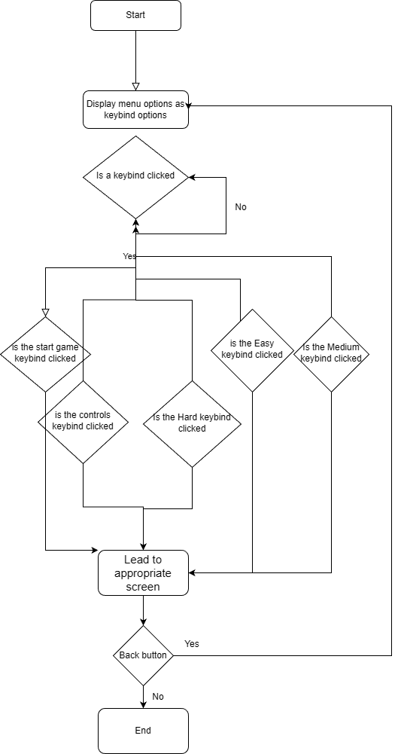

The menu system is the first thing the player will see on the screen once the game is loaded, which is used to navigate through the game. In the main menu the player will see multiple Key binds to attached buttons on the screen; the buttons are start, controls, easy, medium, hard and potentially (leaderboard and quit). If one of the buttons on the screen are clicked the appropriate response is carried out. If the start button is clicked the player displays the game screen, where the player can play the game. If the controls button is clicked, the player is then showed a screen where the controls are displayed.

Flow chart of the fundamentals of the game.
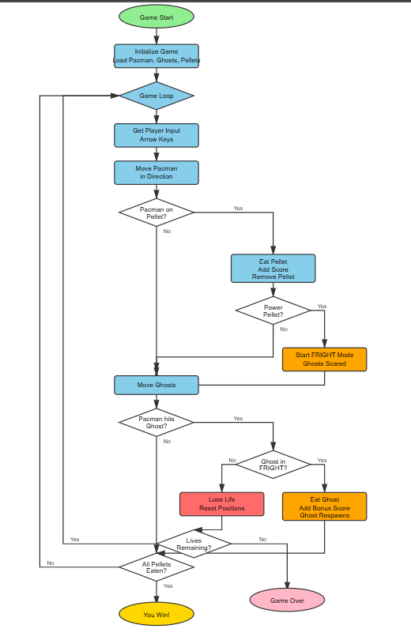

The game begins at game start, where all the core elements of the game are prepared

